



Here is the list of **U.S. states and their abbreviations** in three columns:

|  |  |  |  |  |  |
| --- | --- | --- | --- | --- | --- |
| **State Name** | **Abbreviation** | **State Name** | **Abbreviation** | **State Name** | **Abbreviation** |
| Alabama | AL | Kentucky | KY | North Dakota | ND |
| Alaska | AK | Louisiana | LA | Ohio | OH |
| Arizona | AZ | Maine | ME | Oklahoma | OK |
| Arkansas | AR | Maryland | MD | Oregon | OR |
| California | CA | Massachusetts | MA | Pennsylvania | PA |
| Colorado | CO | Michigan | MI | Rhode Island | RI |
| Connecticut | CT | Minnesota | MN | South Carolina | SC |
| Delaware | DE | Mississippi | MS | South Dakota | SD |
| Florida | FL | Missouri | MO | Tennessee | TN |
| Georgia | GA | Montana | MT | Texas | TX |
| Hawaii | HI | Nebraska | NE | Utah | UT |
| Idaho | ID | Nevada | NV | Vermont | VT |
| Illinois | IL | New Hampshire | NH | Virginia | VA |
| Indiana | IN | New Jersey | NJ | Washington | WA |
| Iowa | IA | New Mexico | NM | West Virginia | WV |
| Kansas | KS | New York | NY | Wisconsin | WI |
|  |  | North Carolina | NC | Wyoming | WY |

Let me know if you need any modifications! 😊

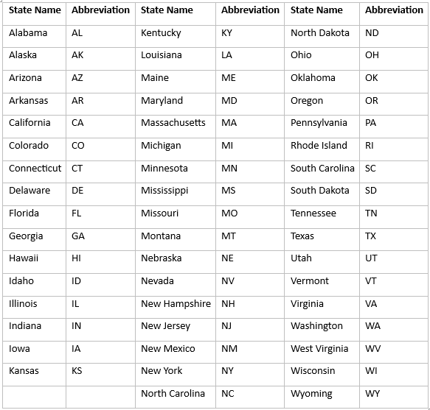

**State Name**

Alabama

Alaska

Arizona

Arkansas

California

Colorado

Connecticut

Delaware

Florida

Georgia

Hawaii

Idaho

Illinois

Indiana

Iowa

Kansas

Kentucky

Louisiana

Maine

Maryland

Massachusetts

Michigan

Minnesota

Mississippi

Missouri

Montana

Nebraska

Nevada

New Hampshire

New Jersey

New Mexico

New York

North Carolina

North Dakota

Ohio

Oklahoma

Oregon

Pennsylvania

Rhode Island

South Carolina

South Dakota

Tennessee

Texas

Utah

Vermont

Virginia

Washington

West Virginia

Wisconsin

Wyoming